

**UNIVERSITY OF PETROLEUM AND ENERGY STUDIES**

**School of Computer** **Science**

**2020-21**

**GRAPHICS AND ANIMATION TOOLS LAB**

**Faculty: Dr. DURGANSH SHARMA**

**Assistant Professor**

**Department of Cybernetics.**

**School of Computer Science, UPES**

**Submitted By:**

**Name- Vaibhav Kansal**

**Roll no-R100217086**

**Batch-B3**

**Semester- 7**

**Course-B.tech. CSE-OSOS**

**Sap Id- 500061579**

**EXPERIMENT NO 7- Design of Rocket using Blender**

**STEPS :-**

1.Open Blender workspace deletes the existing cube and Click on the add option and add a cylinder.

2.Then we will make some adjustments in the cylinder like radius and depth.

3. Select the bottom face of the cone and extrude it downwards in the z-axis till the length of the extruded part is twice the height of the cone.

4. Again extrude a small portion from the bottom face and then extrude it upwards in the z-direction to give a hollow look at the bottom of the rocket.

5.At last create three material colors red, silver, and blue and add a metallic property to them.

6.Select a particular part of the rocket and assign a suitable color to it

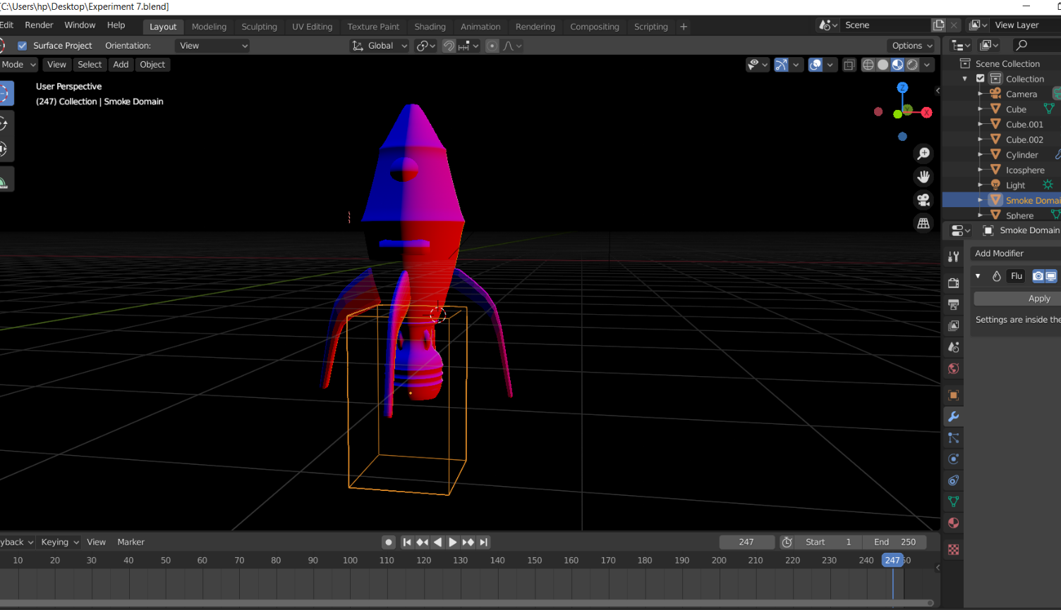

**Link of google drive-** https://drive.google.com/drive/folders/11-Z7Uzd_hixYsWJfe-XCad1ZGPGjlRGn?usp=sharing